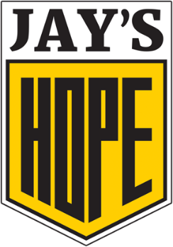
Third Annual “Back to Business” Golf Tournament
June 24, 2019 . Eagle Brook Country Club . Geneva, Illinois
SPONSORSHIPS
Eagle Sponsor $8,000
- Two foursomes Corporate logo/name displayed on three hole signs
- Corporate logo/name added to all tournament materials
- Corporate logo/name displayed at tournament awards dinner

Birdie Sponsor $4,000
- One foursome
- Corporate logo/name displayed on two hole signs
- Corporate logo/name displayed at tournament awards dinner

Bogey Sponsor $1,500
- One foursome
- Corporate logo/name displayed on one hole sign

Par Sponsor $500
- Two golf tickets
- Corporate logo/name displayed on sign at registration

Beverage Cart Sponsor $2,500
- One foursome
- Signage on beverage carts during the event

Hole Sponsor $1,000
- Corporate logo/name displayed on one hole sign

Silent Auction Item: A silent auction will be held from the time of check-in throughout the tournament awards dinner. All donors and items will be included on the website and on silent auction signage.
Donor name: __________________________________________________________
Donor email: __________________________________________________________
Auction item/description: ________________________________________________
Value: ________________________________________________________________
How would you like to be recognized: ______________________________________________________________________

Sponsorships can be submitted online via credit card. For check submissions, please complete this form and email it to:
Kellyjo.golson@advocatehealth.com
Checks can be emailed to:
Kelly Jo Golson
Chief Marketing Officer
Advocate Aurora Health
3075 Highland Parkway, Suite 600
Downers Grove, IL 60515

